4- Selenium

80-90% we use Xpath (XML Path) to locate web elements.
XPath is an address of the element.
DOM - Document Object Model

2 types of xpath:
1) Absolute xpath(full xpath)
Ex: /html/body/header/div/div/div[2]/div/input

2) Relative xpath(partial xpath)
Ex: //*[@name="search"]

Which xpath will be prefered?
Relative xpath. Because Developer keeps changing UI, which may lead to change in Absolute path of an element leading to break in automation script.

Difference between Absolute & Relative xpaths?
------------------
1) Absolute xpath starts with / ---> represents root node
Relative xpath starts with //

2) Abosulate xpath do not use attributes
Relative xpath works with attribute

3) Absolute xpath traverse through each node till it finds element
Relative xpath directly jump and find the element by using attribute

Relative xpath:
Syntax:
//tagname[@attribute='value']
//*[@attribute='value']

Can be generated through:
1) Automatically - Devtools, selectorshub
2) Manually(own xpath)

1) Xpath with single attribute
driver.findElement(By.xpath("//input[@placeholder='Enter Your Name']")).sendKeys("Tanya Coder");

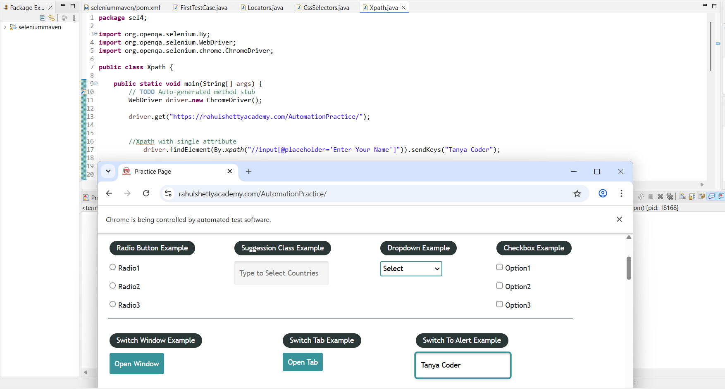

2) Xpath with multiple attributes
driver.findElement(By.xpath("//input[@name='enter-name'][@placeholder='Enter Your Name']")).sendKeys("Tanya Coder");

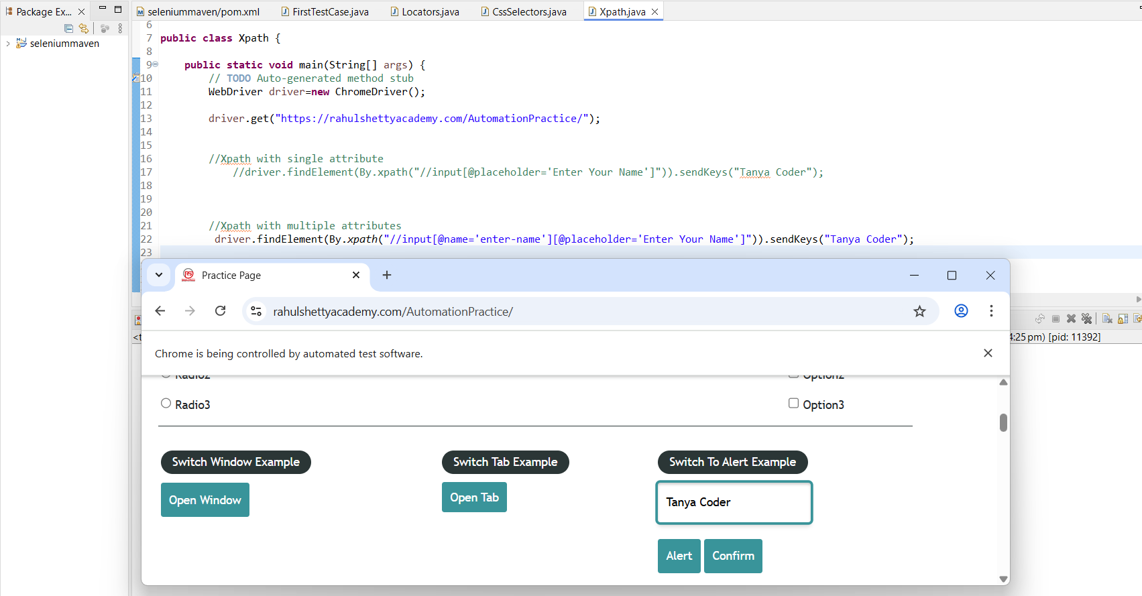

3) Xpath with 'and' 'or' operator

driver.findElement(By.xpath("//input[@name='enter-name' and @placeholder='Enter Your Name']")).sendKeys("Tanya Coder");
driver.findElement(By.xpath("//input[@name='enter-name' or @placeholder='xyz']")).sendKeys("Tanya Coder");

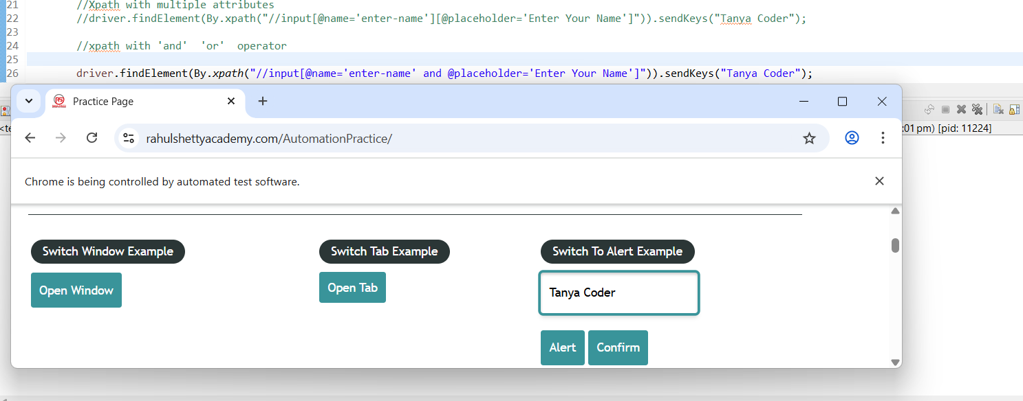

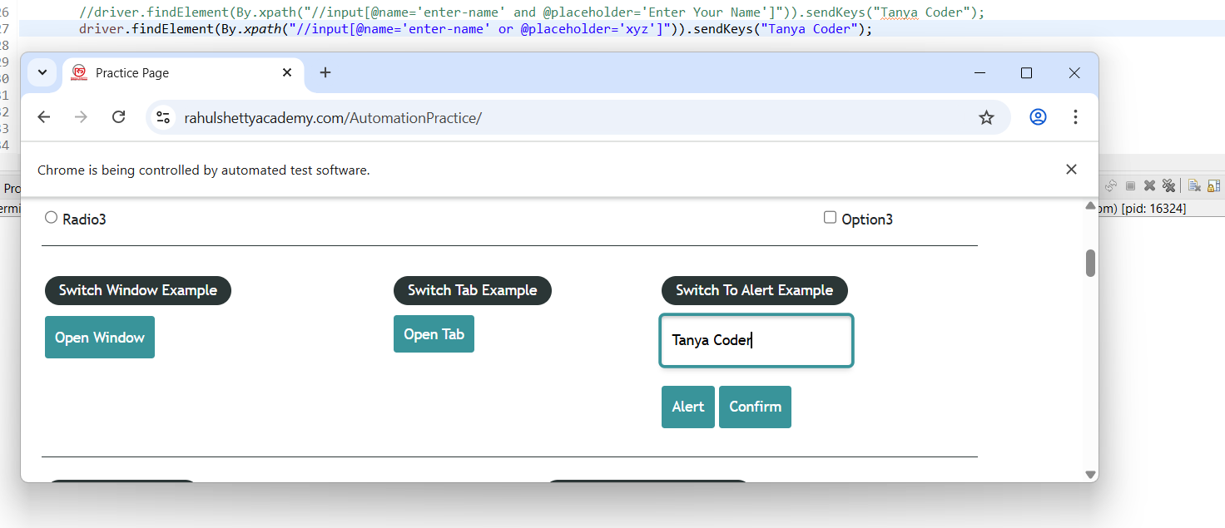

4) xpath with text() - inner text

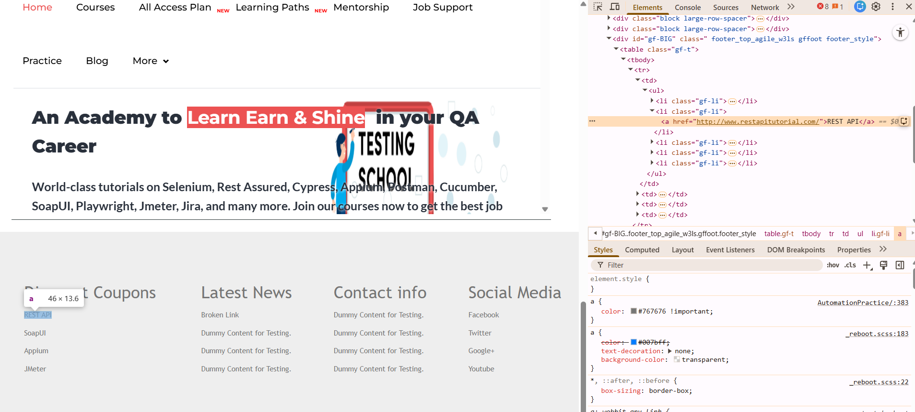
driver.findElement(By.xpath("//*[text()='REST API']")).click();
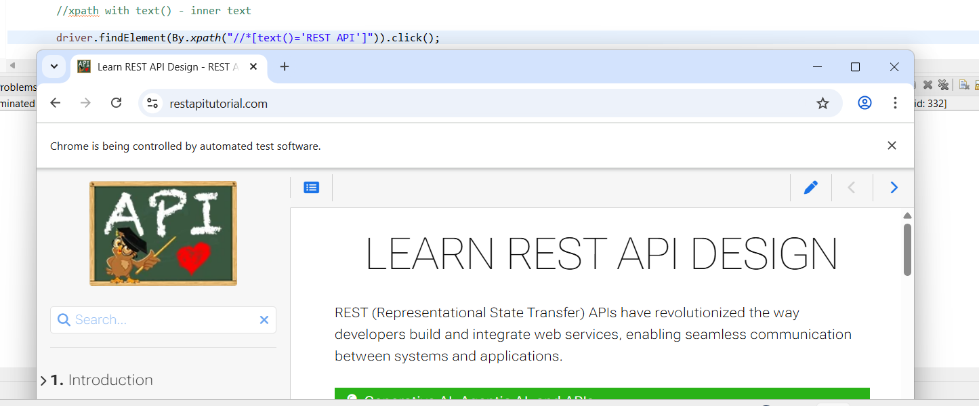
boolean displaystatus=driver.findElement(By.xpath("//h1[text()='Practice Page']")).isDisplayed();
System.out.println(displaystatus);

String value=driver.findElement(By.xpath("//h1[text()='Practice Page']")).getText();
System.out.println(value);

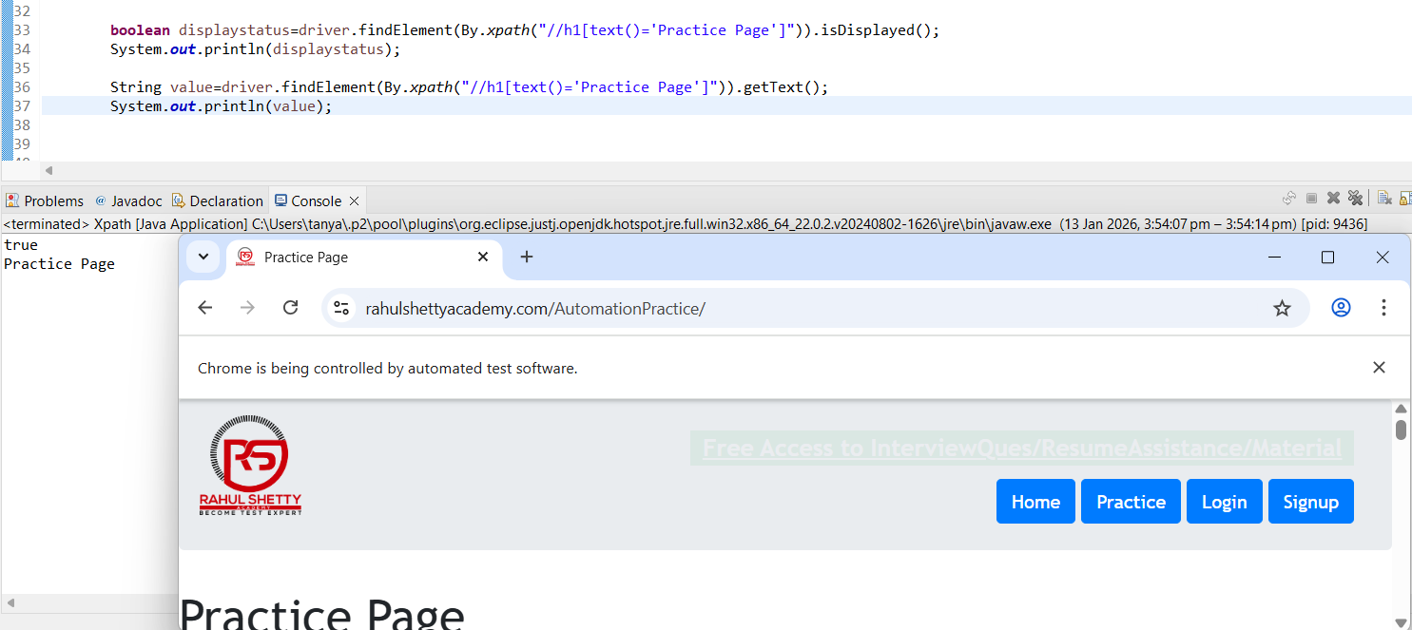

5) xpath with contains()
driver.findElement(By.xpath("//input[contains(@placeholder,'Enter')]")).sendKeys("Tanya coder");

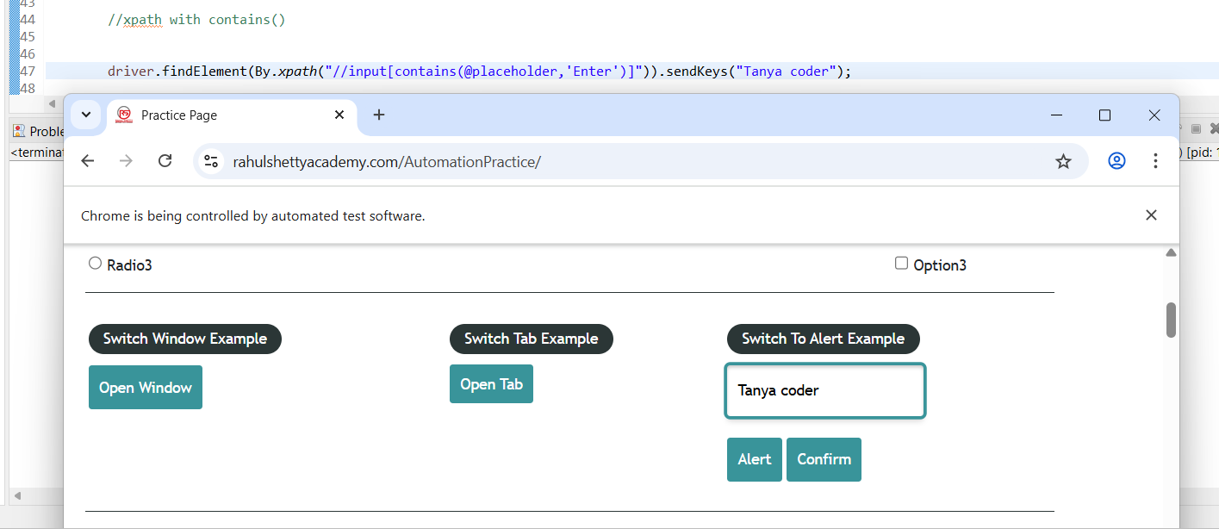
6)xpath with starts-with()
driver.findElement(By.xpath("//input[starts-with(@placeholder,'Enter')]")).sendKeys("Tanya coder");

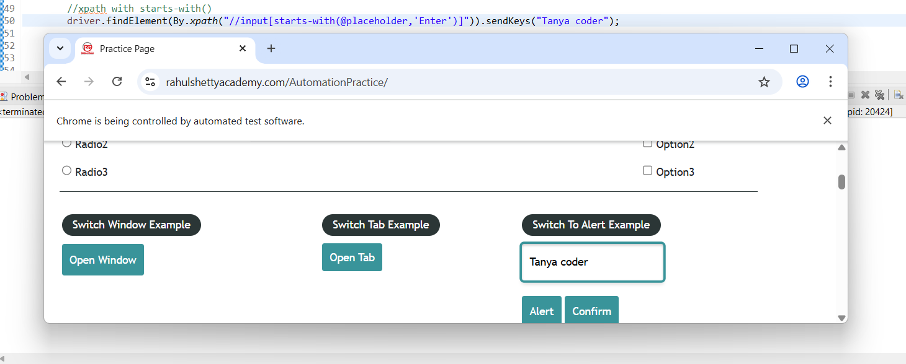

For handling dynamic attributes i.e., where the value of the attribute changes at runtime like id changing from start to stop and stop to start. This is where we have to manually write the xpath on our own using contains() and starts-with() methods, can't take help of automatic xpath generators.

7) chained xpath
boolean status=driver.findElement(By.xpath("//header[@class='jumbotron text-center header_style']//div")).isDisplayed();
System.out.println(status);

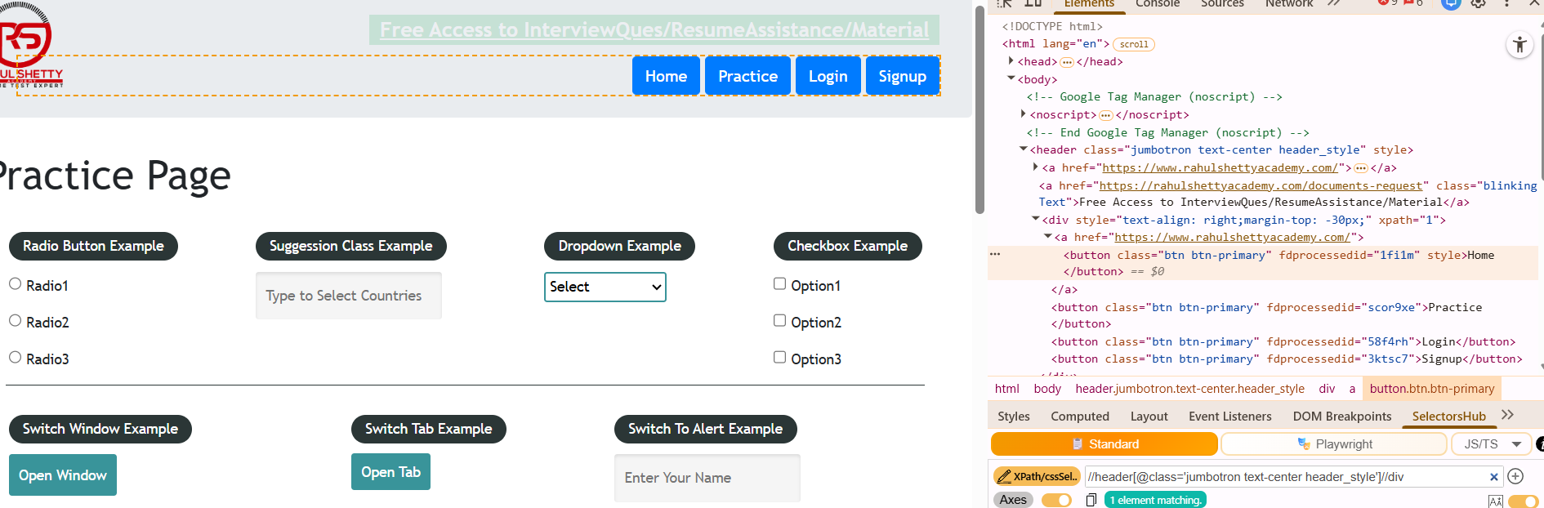

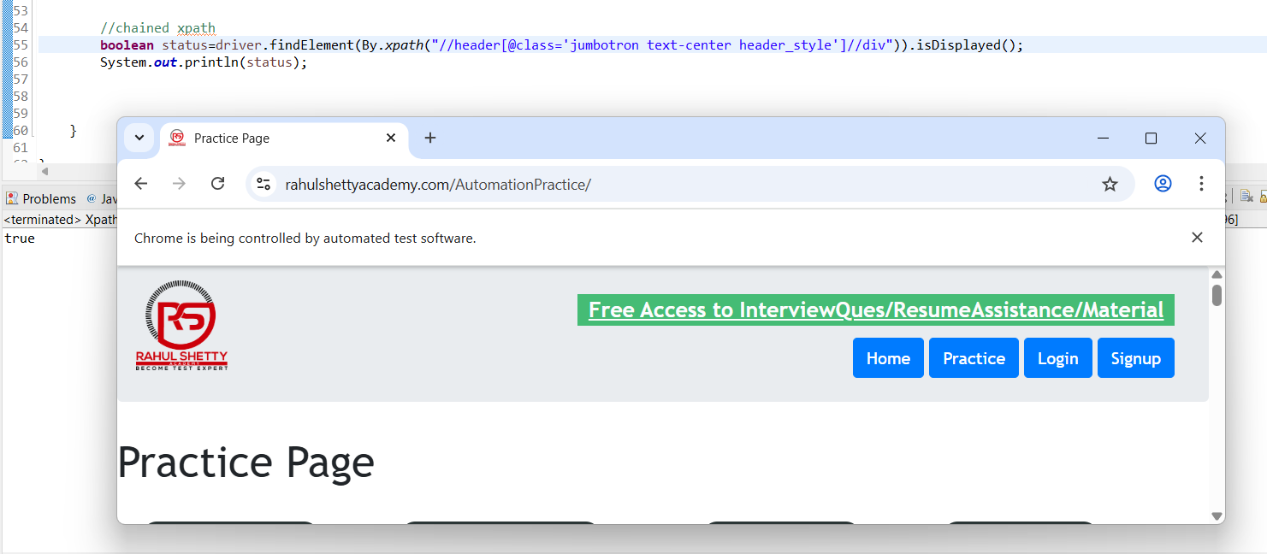

This is used when we are unable to find any attribute or innertext. We start from the parent tag which has attribute or innertext and then connect to our target element. This is nothing but combination of relative and absolute xpaths.

Note:
cssSelector --> top-down (unidirectional only)
xPath --> all directions i.e., down-top also --> possible through xpath axes

